1. 설계

* [gpt-boot store sample 설계 데이터](https://docs.google.com/spreadsheets/d/1GH153RlLSNGzRoznAnRrR27ugajiiPOxE5S5n_ofsU0/edit?usp=drive_link)

1. <https://start.spring.io/> 에서 spring boot 프로젝트 생성
   1. Dependencies : Spring Web, H2 Database, Spring Data JPA, Spring Security,lombok
   2. 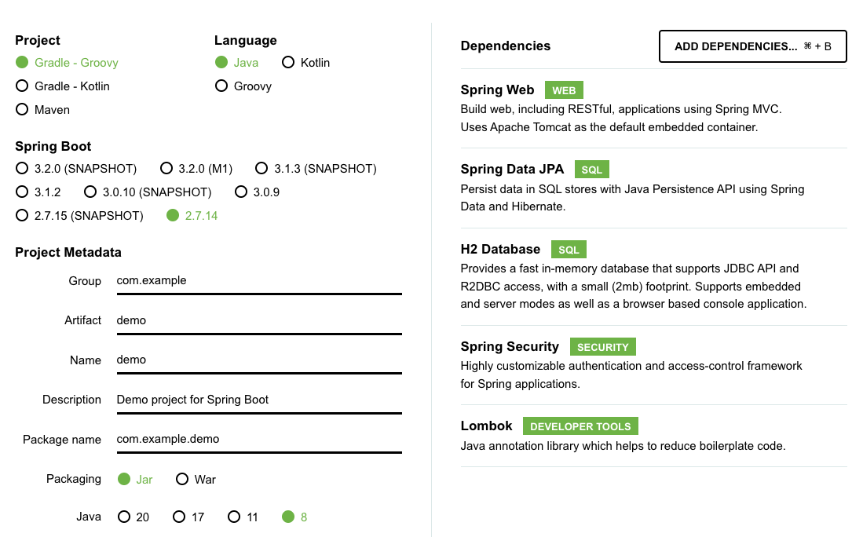
2. 데이터로 질문 시작
   1. I am trying to create a book management service with Java and Spring Boot. Design a domain based on the information below.

**위 설계 데이터를 csv로 변형하여 붙여 넣기(shift enter 키 로 줄바꿈)**

1. entity 코드 작성
   1. Q: "I use Spring Data JPA with lombok. Please write the Book Entity code." 생성된 entity에 book category many to one 관계로 추가되어 있지 않으면 추가해 달라고 추가 요청(Q: add book category to book entity)
   2. Q: "I use Spring Data JPA. Please write the BookCategory Entity code."
2. Repository Service Controller 코드 작성
   1. Q: "Please write the BookRepository code."
   2. Q: "Please write the BookCategoryRepository code."
   3. Q: "Please write the BookService code."
   4. Q: "Please write the BookCategoryService code."
   5. Q: "Please write the BookController code."
   6. Q: "Please write the BookCategoryController code."
3. 실제 프로젝트 실행
4. Security
   1. "Please write spring security configuration code."
5. 테스트 코드
   1. Q : Please write the test code with mokito
6. readme
   1. Q : Please make the Readme.md file